Veterinary Details:
Veterinary Surgeon:

…………………………..………………………… M.R.C.V.S

Details Galen Therapist Requesting Consent:

Name: Alison McHendry of Samadhi Canine Therapies
Mob: 0742 350 5007
Email: samadhi.caninetherapies@gmail.com

Professional Indemnity and Public Liability Insurance Policy details:
Aspen Insurance UK Limited HEAX25HY01

Details of Dog:
Dog's Name:
Handler's Name:
Handler's Address:
E-Mail:
Tel No:

Reason for treatment:

Veterinary Diagnosis:

Relevant pre-existing conditions:

I consent to Alison McHendry of Samadhi Canine Therapies, performing Canine Myotherapy Treatment (soft tissue manipulation, and other massage techniques including Passive Movement Exercises) where appropriate, for soft tissue, specifically muscular conditions on the above-named dog.

Written report: YES / NO

Email Report:* YES / NO

*email address:

I understand that by giving consent, I am not responsible for any Myotherapy treatment given and the provision of professional indemnity insurance for this is the responsibility of Alison McHendry of Samadhi Canine Therapies.

Signed: M.R.C.V.S.

Date:
(Veterinary Surgeon)

PLEASE RETURN THE ABOVE SIGNED FORM TO: samadhi.caninetherapies@gmail.com

What is Galen Myotherapy®?
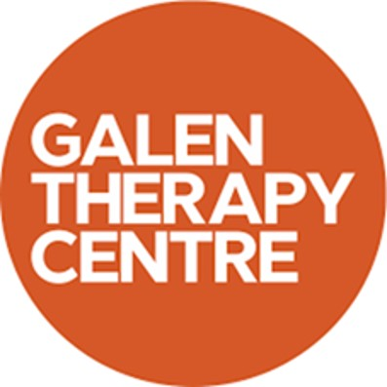
Galen Myotherapy is a specific complementary therapy specialising in
the treatment of damaged or injured muscle and allied soft tissue,
especially chronic muscle pain. Chronic muscle pain is underestimated
and difficult to treat, we work using specialised knowledge and training
specifically, within this area.

Muscular issues can manifest themselves in many different ways. The pain can cause stress that will have a negative effect on how the dog functions both physically and psychologically.
Galen Myotherapy promotes muscle function especially that caused through injury, compensatory or repetitive strain issues. This results in improved mobility, performance and a reduction in pain perception therefore reducing stress and allied symptoms.

By treating the secondary and/or compensatory issues, Galen Myotherapy can be part of a highly effective management programme for supporting the following conditions;
- Osteoarthritis
- Hip/Elbow Dysplasia
- CDRM
- Cruciate issues
- OCD
- Spondylitis.

A Galen Myotherapy® professional only works on dogs that have a signed Veterinary consent form and adheres to the Veterinary Act.

(The Veterinary Surgery (Exemptions) Order 1962 allows for the treatment of animals by physiotherapy, provided that the animal has first been seen by a veterinary surgeon who has diagnosed the condition and decided that it should be treated by physiotherapy under his/her direction. 'Physiotherapy' is interpreted as including all kinds of manipulative therapy (therefore including Galen Myotherapy®)

Websites: https://www.galenmyotherapy.co.uk/vets

